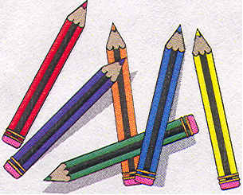
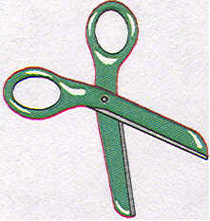
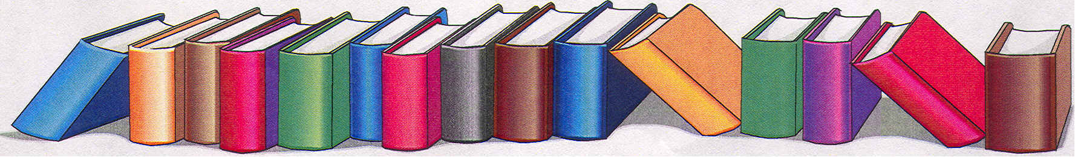

NEW VISION LEARNING ACADEMY
2026-2027 School Supply List
"

,

Pre-Kindergarten
First Grade

Heavy Duty Clear Transparent See Through
Book-Bag (ONLY)

4–50 Count Antibacterial Hand Wipes
2 Bottles of Antibacterial Soap
3 Large Containers of Clorox Wipes
2 - 19.5 oz. Blue cans of Lysol Spray
4 Large Boxes of Kleenex
4 Large Rolls of Paper Towels
4 Boxes of 16 or 24 Crayola Crayons
1 Box of Crayola Washable Markers
3 Packs of Wide Ruled Loose-Leaf Paper
48 Sharpened #2 Pencils
2 Vinyl Pocket Folders with Prongs (2 Blue)
No decorated, paper wrapped or mechanical pencils
8 - 8 oz. Bottles of Water

Technology Class
2-Large boxes of Kleenex
1-19.5 oz. Blue cans of Lysol Spray
1-Large Container of Clorox Wipes

Heavy Duty Clear Transparent See Through
Book-Bag (ONLY)

4–50 Count Antibacterial Hand Wipes
2 Bottles of Antibacterial Soap
3 Large Containers of Clorox Wipes
2 - 19.5 oz. Blue cans of Lysol Spray
1 Box of Wet Wipes
4 Large Boxes of Kleenex
4 Large Roll of Paper Towels
6 Boxes of Crayola “Large Crayons”
1 Large Box Ticonderoga Tri-write Pencils
8 - 8 oz. Bottles of Water

Technology Class
2-Large boxes of Kleenex
1-19.5 oz. Blue cans of Lysol Spray
1-Large Container of Clorox Wipes

Heavy Duty Clear Transparent See Through
Book-Bag (ONLY)

4–50 Count Antibacterial Hand Wipes
2 Bottles of Antibacterial Soap
3 Large Containers of Clorox Wipes
2 - 19.5 oz. Blue cans of Lysol Spray
4 Large Boxes of Kleenex
4 Large Rolls of Paper Towels
2 Boxes of 16 or 24 Crayola Crayons
48 Sharpened #2 Pencils
No decorated, paper wrapped or mechanical pencils
1-3 Subject Notebook (Wide Ruled)
2 Vinyl Pocket Folders with Prongs (1 Green, 1 Yellow)
3 Packs of Wide Ruled Loose-Leaf Paper
8 - 8 oz. Bottles of Water

Technology Class
2 Large boxes of Kleenex
1 - 19.5 oz. Blue cans of Lysol Spray
1 Large Container of Clorox Wipes

Second Grade

Heavy Duty Clear Transparent See Through
Book-Bag (ONLY)

4–50 Count Antibacterial Hand Wipes
2 Bottles of Antibacterial Soap
3 Large Containers of Clorox Wipes
2 - 19.5 oz. Blue cans of Lysol Spray
4 Large Boxes of Kleenex
4 Large Rolls of Paper Towels
10 Boxes of Crayola “Large Crayons”
48 Sharpened #2 Pencils
No decorated, paper wrapped or mechanical pencils
8 - 8 oz. Bottles of Water

Technology Class
2 Large boxes of Kleenex
1 - 19.5 oz. Blue cans of Lysol Spray
1 Large Container of Clorox Wipes

Kindergarten

NEW VISION LEARNING ACADEMY
2026-2027 School Supply List

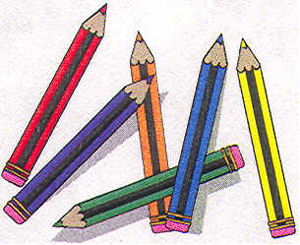
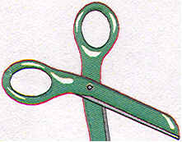

Fourth Grade

Sixth Grade

Heavy Duty Clear Transparent See Through
Book-Bag (ONLY)

4–50 Count Antibacterial Hand Wipes
2 Bottles of Antibacterial Soap
3 Large Containers of Clorox Wipes
2 - 19.5 oz. Blue cans of Lysol Spray
4 Large Boxes of Kleenex
4 Large Rolls of Paper Towels
2 Yellow Highlighters
48 Sharpened #2 Pencils
No decorated, paper wrapped or mechanical pencils
1 Pack of Colored Pencils
1 Pack of Ball Point Pens (Black, Blue & Red)
1 Bendable Ruler with inches & centimeters
2 Vinyl Pocket Folders with Prongs (1 Red, 1 Green)
3 Packs of Wide Ruled Loose-Leaf Paper
1 Dictionary
8 - 8 oz. Bottles of Water

Technology Class
2 Large boxes of Kleenex
1 - 19.5 oz. Blue cans of Lysol Spray
1 Large Container of Clorox Wipes

Heavy Duty Clear Transparent See Through
Book-Bag (ONLY)

4–50 Count Antibacterial Hand Wipes
2 Bottles of Antibacterial Soap
3 Large Containers of Clorox Wipes
2 - 19.5 oz. Blue cans of Lysol Spray
4 Large Boxes of Kleenex
4 Large Rolls of Paper Towels
2 Yellow Highlighters
48 Sharpened #2 Pencils
No decorated, paper wrapped or mechanical pencils
1 Bendable Ruler with inches & centimeters
4 Vinyl Pocket Folders with Prongs (2 Red, 2 Blue)
3 Packs of Wide Ruled Loose-Leaf Paper
2-3 Subject Notebooks
2 Black Expo Dry Erase Markers
8 - 8 oz. Bottles of Water

Technology Class
2 Large boxes of Kleenex
1 - 19.5 oz. Blue cans of Lysol Spray
1 Large Container of Clorox Wipes

Third Grade

Heavy Duty Clear Transparent See Through
Book-Bag (ONLY)

4–50 Count Antibacterial Hand Wipes
2 Bottles of Antibacterial Soap
3 Large Containers of Clorox Wipes
2 - 19.5 oz. Blue cans of Lysol Spray
4 Large Boxes of Kleenex
4 Large Roll of Paper Towels
2 Boxes 16 or 24 Crayola Crayons
2 Yellow Highlighters
1 Pack of Colored Pencils
48 Sharpened #2 Pencils
No decorated, paper wrapped or mechanical pencils
1 Pair of Child Size Fiskars Scissors
1 Bendable Ruler with inches & centimeters
2-3 Subject Notebooks
3 Packs of Wide Ruled Loose-Leaf Paper
2 Vinyl Pocket Folders with Prongs (1 Red, 1 Blue)
8 - 8 oz. Bottles of Water

Technology Class
2-Large Boxes of Kleenex
1 - 19.5 oz. Blue can of Lysol Spray
1 Large Container of Clorox Wipes

2 Large cans of Lysol or Microban disinfectant Spray
k

Fifth Grade

Heavy Duty Clear Transparent See Through
Book-Bag (ONLY)

4–50 Count Antibacterial Hand Wipes
2 Bottles of Antibacterial Soap
3 Large Containers of Clorox Wipes
2 - 19.5 oz. Blue cans of Lysol Spray
4 Large Boxes of Kleenex
4 Large Rolls of Paper Towels
2 Yellow Highlighters
72 Sharpened #2 Pencils
No decorated, paper wrapped or mechanical pencils
1 Pack of Ball Point Pens (Black, Blue & Red)
1 Bendable Ruler with inches & centimeters
3 Packs of Wide Ruled Loose-Leaf Paper
1 Dictionary /Thesaurus
2 Vinyl Pocket Folders with Prongs (1 Red, 1 Green)
8 - 8 oz. Bottles of Water

Technology Class
2 Large Boxes of Kleenex
1 - 19.5 oz. Blue can of Lysol Spray
1 Large Container of Clorox Wipes

